First Trimester:
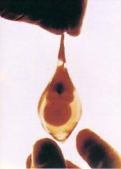
This remarkable photograph of a tiny fetus in its unruptured amniotic sac was taken after surgery for an ectopic pregnancy in 1972. This picture demonstrates the development of a baby at only six weeks after conception.
Photograph by University of Minnesota Medical Photographer, Robert Wolfe.

Week 2
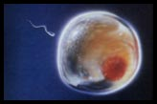
Fertilization, the joining of the sperm and the egg in the fallopian tube (below) to form a unique human being, occurs. Forty-six chromosomes provide the blueprint for the embryo’s physical characteristic
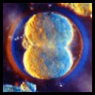
The picture on the right is a fertilized egg only thirty hours after conception. Magnified here, it is no larger than the head of a pin. Still rapidly dividing, the developing embryo, called a zygote at this stage, floats down from the fallopian tube and towards the uterus.

Week 3
At this point, the blastocyst, or developing embryo, is looking for a spot to implant in the uterus. Early formation of the central nervous system, backbone, and spinal column has begun. The gastrointestinal system has also begun to develop with the kidneys, liver, and intestines forming. The heart has begun to form.

Week 4
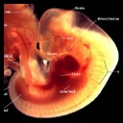
Hormones produced by the embryo stop the mother’s menstrual cycle.

Week 5
The embryo’s tiny heart begins to beat by day twenty-one. The brain has developed into 5 areas and some cranial nerves are visible. Arm and leg buds are visible and the formation of the eyes, lips, and nose has begun. The spinal cord grows faster than the rest of the body giving a tail like appearance which disappears as the embryo continues to grow. The placenta begins to provide nourishment for the embryo.

Week 7
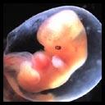
Major organs have all begun to form. The embryo has developed its own blood type, unique from the mother’s. Hair follicles and nipples form and knees and elbows are visible. Facial features are also observable. The eyes have a retina and lens. The major muscle system is developed and the embryo is able to move.

Week 8
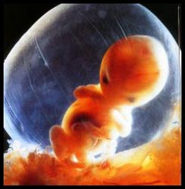
The embryo is reactive to its environment inside the amniotic sac where it swims and moves. Hands and feet can be seen. At the end of week 8, the embryonic period is over and the fetal stage begins.

Weeks 9-12
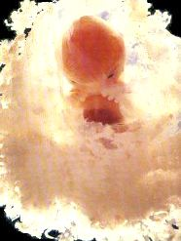
The heart is almost completely developed and the heart rate can be heard on a Doppler machine at the doctor’s office. Most major organs and tissues have developed and red blood cells are now produced in the liver. The face is well formed and the eyes are almost fully developed. The eyelids will close and not reopen until the 28th week. Arms, hands, fingers, legs, feet, and toes are fully formed. Nails and earlobes start to form and tooth buds develop in the gums. Fetus can make a fist with its finger. Testosterone (male sex hormone) is produced by the testes in male fetus.

2nd Trimester

18 weeks gestation (16 weeks since conception)
“Life is present from the moment of conception.”
Dr. Jerome Lejeune, late professor and world renowned geneticist, University of Descarte, Paris
“A person’s a person, no matter how small!”
Excerpted from “Horton Hears a Who,” by Dr. Seuss, late famous children’s author

Weeks 13-16
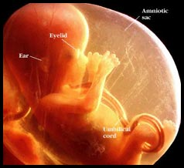
The brain is fully developed and the fetus can suck, swallow, and make irregular breathing sounds. Fetus can feel pain (New England Journal of Medicine). Fetal skin is almost transparent. Muscles tissue is lengthening and bones are becoming harder. Liver and organs produce appropriate fluids. Eyebrows and eyelashes appear and the fetus makes active movements including kicks and even somersaults.
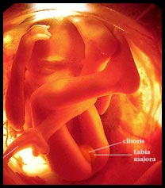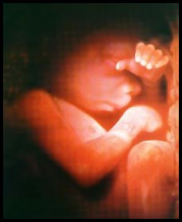

Week 20
“Quickening” (when the mother can feel the fetus moving) usually occurs around this time. Finger and toenails appear. Lanugo, a fine hair now covers the entire body. The fetus can hear and recognize the mother’s voice. Sex organs are visible on ultrasound devices.

Third Trimester:

Week 24
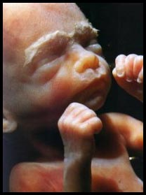
A protective waxy substance called Vernix covers the skin. By birth, most of the Vernix will be gone but any that is left is quickly absorbed. Fetus has a hand and startle reflex. Footprints and fingerprints are forming. Fetus practices breathing by inhaling amniotic fluid into its developing lungs.

Weeks 25 - 28
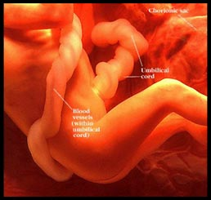
Rapid brain development occurs during this period and the nervous system is able to control some bodily functions. The fetus’ eyelids now open and close. At 25 weeks there is a 60% chance of survival if born. The fetus is considered legally viable at 28 weeks and there is a 90% chance of survival if born at this point.

Weeks 29 - 32
There is a rapid increase in the amount of body fat the fetus has. Rhythmic breathing occurs, but the lungs are not yet mature. The fetus sleeps 90-95% of the day. At this point there the survival rate is above 95% if the baby is born.
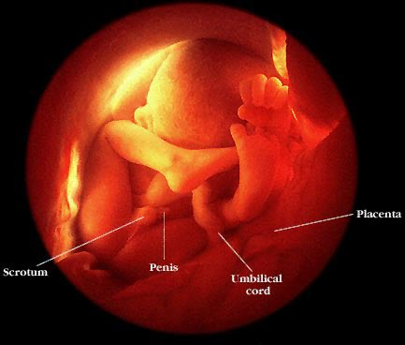

Weeks 38 - 40
The fetus is considered full-term. Lanugo is gone except on upper arms and shoulders. Hair on the baby’s head is now coarser and thicker. The lungs are mature. The average weight of the baby at this point is seven and a half pounds. At birth the placenta detaches from the uterus and the umbilical cord will be cut as the baby takes his first breaths of air. Breathing will trigger changes in the heart and bypass arteries forcing all blood to now travel through the lungs.
