I.Q., Gifted Students, and “Nature vs. Nurture”
Class Outline
Febrary 19, 2009

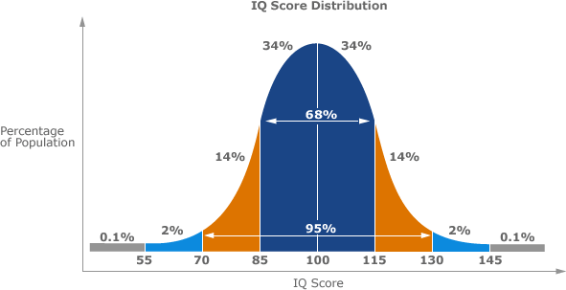

I. Introduction
- POLL Questions: Personal Experience

II. What is Intelligence? How is it determined?
- What (if any) is the neurological basis for intelligence?
http://www.ccbi.cmu.edu/reprints/Newman_Sternberg-chapt-2005-intelligence.pdf
- “Smart Genes” : http://www.time.com/time/magazine/article/0,9171,991939-1,00.html
- Are I.Q. tests legitimate?
- Concept of “multiple intelligences” : http://iq-test.learninginfo.org/iq02.htm
- “Watching Prodigies for the Dark Side” : http://www.sciam.com/article.cfm?id=watching-prodigies-for-th

III. Nature vs. Nurture
- “Gifted Children: How to Bring Out Their Potential” – Hard Work or Built-in Limits?
http://www.sciam.com/article.cfm?id=coaching-the-gifted-child

IV. “Gifted” Students
- Statistics - http://www.time.com/time/magazine/article/0,9171,1653653,00.html
- Magnet Schools
- Case Study: New York City gifted program reform:
http://www.nytimes.com/2008/10/30/nyregion/30gifted.html?_r=1&fta=y
- Does “diversity” matter in gifted education?
http://www.nytimes.com/2008/06/19/nyregion/19gifted.html?ref=education
- Vanderbilt Programs for Talent Youth
- Vanderbilt Summer Academy
- Weekend Academy at Vanderbilt University

Questions:
- Why is there a different value placed on IQ testing versus standardized testing?
- What if brain scan could tell us your capacity to learn? Is it ethical?
- Is it ethical to "tailor" education like "tailored" marketing?
- If private schools were banned and everyone had to go to public schools, would their quality improve?

